Lesson 6 updating data in context adding a toggle button

<https://www.youtube.com/watch?v=bJXAHHpyVes&list=PL4cUxeGkcC9hNokByJilPg5g9m2APUePI&index=6>

toggle function lives in class

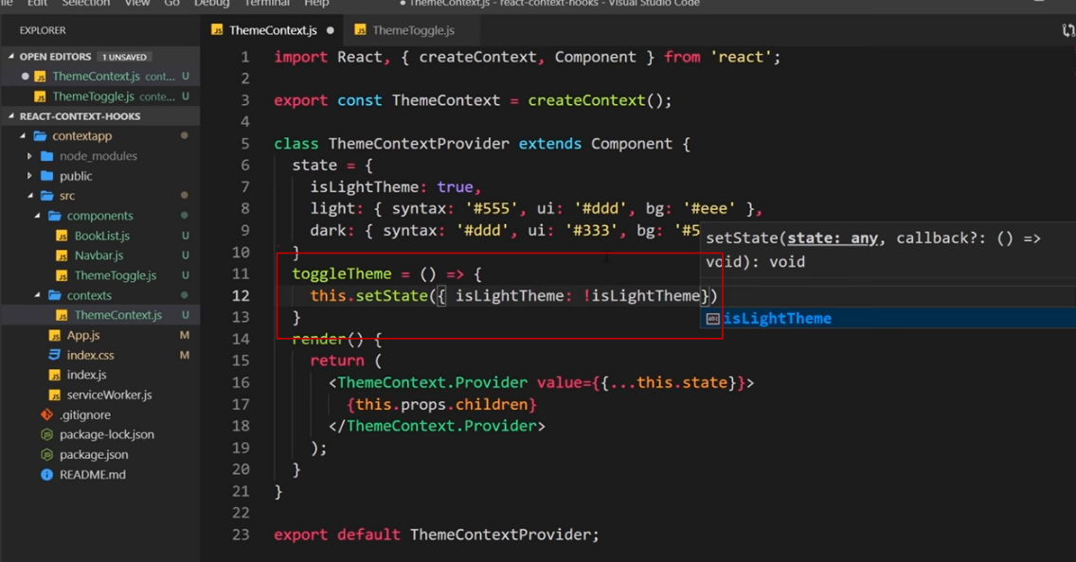

Pass the function as a prop 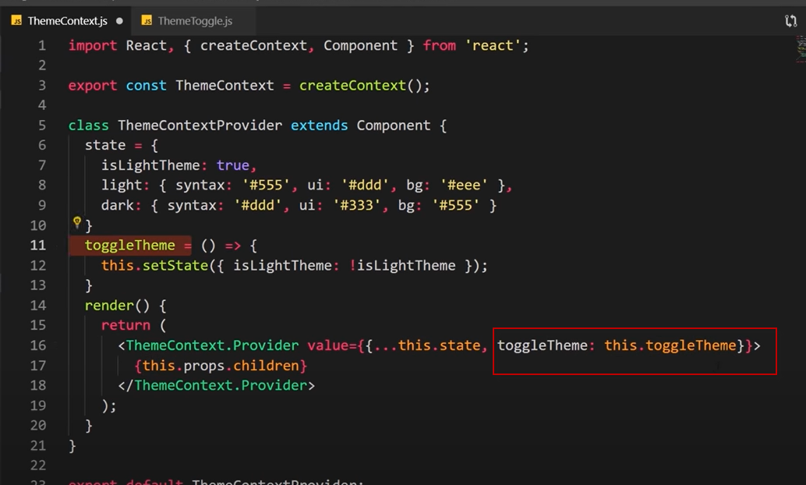

Now have access in any component that consumes this context.

Interact with data and change it – define function inside class which can edit the state and then pass that function into the value property of the provider. Therfore when we consume the context we have access to that function and can do something with it.